Natural Language Workflow Generator
Compile plain-English business rules into validated, executable DAG workflows with human-in-the-loop approvals.

Property | Value
Status | Approved, ready for implementation
Date | 2026-09-28
Owner | Engineering Team
Stack | Streamlit, FastAPI, Groq (Llama 3.3), Pydantic, NetworkX, SQLite3, Graphviz

Table of Contents
- Overview
- Goals and Non-Goals
- Architecture
- Workflow Specification (IR)
- Expressions and Templating
- Compilation Pipeline
- Execution Runtime
- Data Model
- REST API
- Frontend (Streamlit)
- Security Considerations
- Testing Strategy
- Known Inconsistencies and Open Questions
- Local Development

1. Overview
Business users know what should happen ("if a refund exceeds $500, check the fraud score, get manager approval, then issue the Stripe refund") but not how to wire APIs, conditionals, data mappers, and error handlers together.

This system:

- Accepts a natural-language prompt.
- Compiles it, via an LLM, into a strictly typed JSON Directed Acyclic Graph (DAG).
- Validates schema, graph topology, and references.
- Renders the graph interactively (Graphviz in Streamlit).
- Executes it step by step in a FastAPI runtime with SQLite persistence. Execution can pause on human approval and resume after a decision.

Key principle: The runtime never executes free text. It only executes the validated JSON Intermediate Representation (IR).

2. Goals and Non-Goals

Goals
- Deterministic execution from an LLM-generated spec.
- Durable pause/resume for human approvals (survives process restarts).
- Self-healing generation: schema errors are fed back to the LLM.
- Full auditability: every step's input, output, and timing is logged.

Non-Goals (v1)
- Loops or cycles (the graph is strictly a DAG).
- Parallel branch execution / joins (traversal is sequential).
- Multi-tenant auth, RBAC enforcement beyond role labels.
- Production integrations (APIs are mocked or simulated by default).

3. Architecture
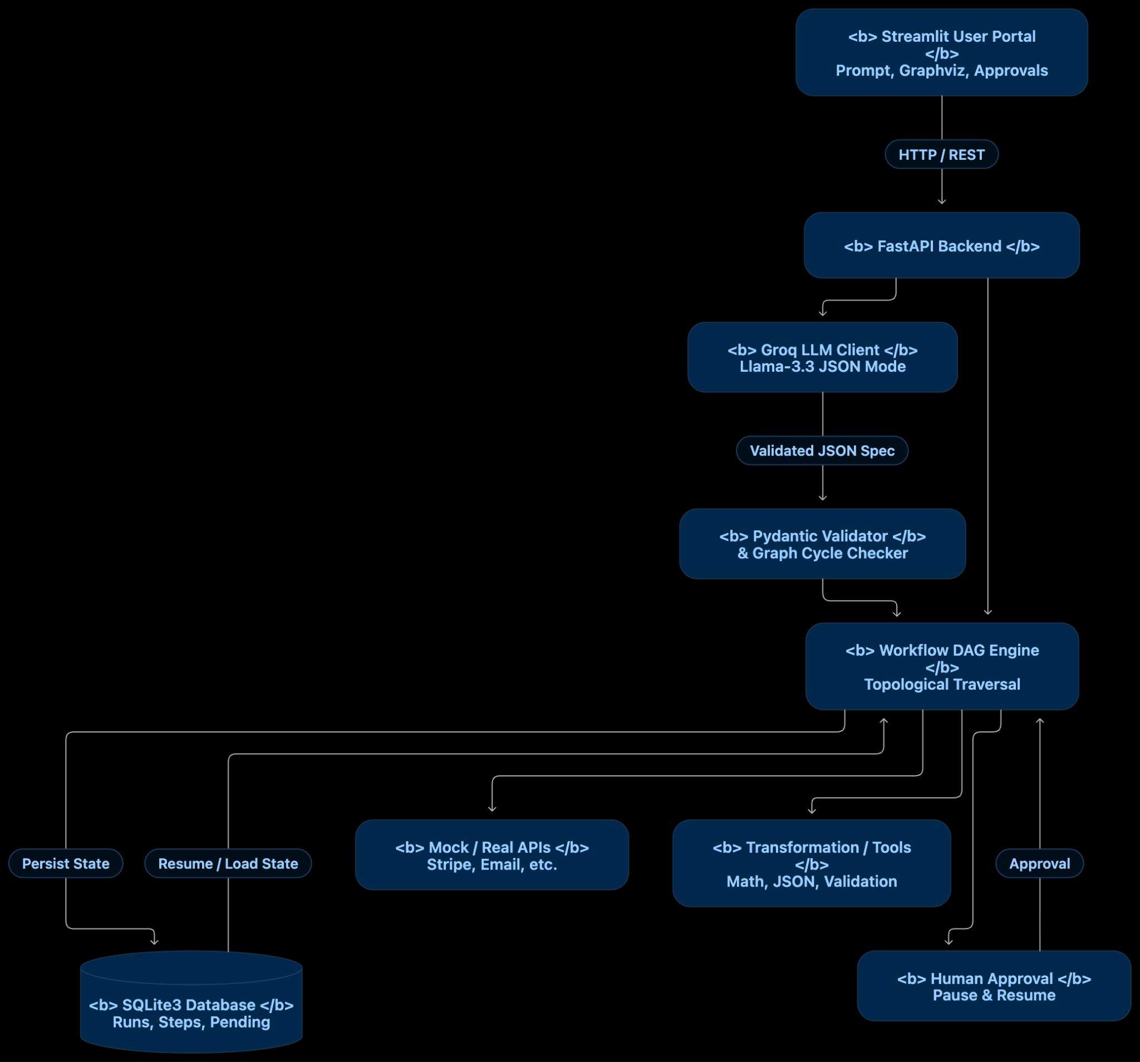

Component | Responsibility
Streamlit portal | Prompt input, graph visualization, runner console, approval gate
FastAPI backend | REST API, orchestration of compile and execute flows
Groq client | Calls Open ai in JSON mode (temperature=0.1)
Validator | Pydantic schema validation, then NetworkX cycle and reachability checks
DAG engine | Node traversal, expression resolution, handler dispatch, retries
SQLite | Durable storage of workflows, executions, step logs, approvals

4. Workflow Specification (IR)

4.1 Top-Level Object
Field | Type | Required | Description
id | string | yes | Unique workflow ID
name | string | yes | Human-readable name
description | string | yes | What the workflow does
entrypoint | string | yes | ID of the first node to execute
sample_input | object | no | Mock trigger payload for testing
nodes | Node[] | yes | Workflow steps
edges | Edge[] | yes | Directed connections

4.2 Node
Field | Type | Required | Description
id | string | yes | Unique within the workflow
type | enum | yes | validation, tool, api, transform, condition, human_approval, notification
label | string | yes | Human-readable step name
description | string | no | Longer description
config | object | no | Type-specific configuration (see 4.4)
on_error | object | no | Error policy (see 4.5)

4.3 Edge
Field | Type | Required | Description
from_node | string | yes | Source node ID
to_node | string | yes | Target node ID
condition_branch | "true", "false", "default" | no | Only valid when the source is a condition node

4.4 Node Type Reference
Type | Responsibility | Key config fields
validation | Check inputs, types, thresholds | rules: [{field, operator, value}]
tool | Deterministic built-in utilities | tool_name, input_mapping
api | HTTP REST call (mock or real) | method, endpoint, headers, payload
transform | Reshape, filter, map data | expression or mapping dict
condition | Boolean branching | expression
human_approval | Suspend and raise an approval ticket | prompt, required_role, timeout_seconds
notification | Email, Slack, etc. | channel, recipient, message

Built-in tools: calculate_tax, sentiment_analysis, fraud_detector / score_fraud, format_date (see 13.1).

4.5 Error Handling (on_error)
Field | Type | Default | Description
retry_count | integer | 0 | Immediate retries before failing
retry_delay_seconds | number | 0 | Backoff between attempts
fallback_node | string | none | Node to route to after retries are exhausted
fail_workflow | boolean | true | Fail the run, or continue with a default value

Resolution order: retry, then fallback_node, then fail_workflow.

4.6 JSON Schema (draft-07)
{

"$schema": "http://json-schema.org/draft-07/schema#",

"title": "ExecutableWorkflow",

"type": "object",

"required": ["id", "name", "description", "entrypoint", "nodes", "edges"],

"properties": {

"id": { "type": "string" },

"name": { "type": "string" },

"description": { "type": "string" },

"entrypoint": { "type": "string", "description": "The ID of the first node to execute" },

"sample_input": { "type": "object", "description": "Mock inputs needed to trigger and test this workflow" },

"nodes": { "type": "array", "items": { "$ref": "#/definitions/Node" } },

"edges": { "type": "array", "items": { "$ref": "#/definitions/Edge" } }

},

"definitions": {

"Node": {

"type": "object",

"required": ["id", "type", "label"],

"properties": {

"id": { "type": "string", "example": "validate_input_1" },

"type": {

"type": "string",

"enum": ["validation", "tool", "api", "transform", "condition", "human_approval", "notification"]

},

"label": { "type": "string" },

"description": { "type": "string" },

"config": { "type": "object" },

"on_error": {

"type": "object",

"properties": {

"retry_count": { "type": "integer", "default": 0 },

"fallback_node": { "type": "string" },

"fail_workflow": { "type": "boolean", "default": true }

}

}

}

},

"Edge": {

"type": "object",

"required": ["from_node", "to_node"],

"properties": {

"from_node": { "type": "string" },

"to_node": { "type": "string" },

"condition_branch": { "type": "string", "enum": ["true", "false", "default"] }

}

}

}

}

4.7 Example: High-Value Refund and Fraud Review
{

"id": "wf_refund_guard_001",

"name": "High-Value Refund & Fraud Review",

"description": "Validates incoming refund request, runs fraud score check, pauses for manager approval if high risk, and triggers Stripe API.",

"entrypoint": "step_validate_request",

"sample_input": {

"refund_id": "REF-9921",

"customer_email": "alex@example.com",

"amount": 750.00,

"reason": "Damaged goods upon delivery"

},

"nodes": [

{

"id": "step_validate_request",

"type": "validation",

"label": "Validate Refund Payload",

"config": {

"rules": [

{ "field": "amount", "operator": ">", "value": 0 },

{ "field": "customer_email", "operator": "contains", "value": "@" }

]

}

},

{

"id": "step_fraud_check",

"type": "tool",

"label": "Calculate Fraud Risk Score",

"config": {

"tool_name": "fraud_detector",

"input_mapping": {

"email": "{{context.customer_email}}",

"amount": "{{context.amount}}"

}

}

},

{

"id": "step_check_threshold",

"type": "condition",

"label": "Is Amount > $500 or Fraud Score > 0.6?",

"config": {

"expression": "context.amount > 500 or context.nodes.step_fraud_check.output.risk_score > 0.6"

}

},

{

"id": "step_manager_approval",

"type": "human_approval",

"label": "Manager Human Approval",

"config": {

"prompt": "Refund of ${{context.amount}} for {{context.customer_email}} exceeds threshold. Approve refund?",

"required_role": "Finance_Manager"

}

},

{

"id": "step_stripe_refund",

"type": "api",

"label": "Call Stripe Refund API",

"config": {

"method": "POST",

"endpoint": "https://api.stripe.mock/v1/refunds",

"payload": {

"amount": "{{context.amount}}",

"reference": "{{context.refund_id}}"

}

},

"on_error": { "retry_count": 2, "fallback_node": "step_notify_failure" }

},

{

"id": "step_notify_customer_success",

"type": "notification",

"label": "Send Refund Confirmation Email",

"config": {

"channel": "email",

"recipient": "{{context.customer_email}}",

"message": "Your refund of ${{context.amount}} has been processed successfully."

}

},

{

"id": "step_notify_failure",

"type": "notification",

"label": "Alert Support on Refund Failure",

"config": {

"channel": "slack",

"recipient": "#finance-ops",

"message": "Refund failed for {{context.refund_id}}."

}

}

],

"edges": [

{ "from_node": "step_validate_request", "to_node": "step_fraud_check" },

{ "from_node": "step_fraud_check", "to_node": "step_check_threshold" },

{ "from_node": "step_check_threshold", "to_node": "step_manager_approval", "condition_branch": "true" },

{ "from_node": "step_check_threshold", "to_node": "step_stripe_refund", "condition_branch": "false" },

{ "from_node": "step_manager_approval", "to_node": "step_stripe_refund" },

{ "from_node": "step_stripe_refund", "to_node": "step_notify_customer_success" }

]

}

5. Expressions and Templating

5.1 Context Shape
{

"<trigger payload keys>": "...",

"nodes": {

"<node_id>": { "output": { } }

}

}

Trigger payload fields are accessed as context.<field>. Prior node results are accessed as context.nodes.<node_id>.output.<field>.

5.2 Template Interpolation
- Syntax: {{context.path.to.value}}, used in string config values (input_mapping, payload, message, prompt, recipient).
- Resolved immediately before a node executes.
- Missing path: raise TemplateResolutionError. This is treated as a node failure, so on_error applies.

5.3 Boolean and Transform Expressions
- Used by condition.expression and transform.expression.
- Must be evaluated by a safe expression evaluator (for example simpleeval or a restricted AST walker). Never use eval().
- Allowed: comparison operators, and/or/not, arithmetic, attribute and index access on context, and a small function whitelist.

6. Compilation Pipeline

6.1 System Prompt Contents
- Strict JSON schema rules for nodes and edges.
- Registry of available tools and APIs (prevents hallucinated endpoints).
- Few-shot examples covering branching, human approval, and fallbacks/transforms.
- Node ID naming convention (see 13.4).

6.2 Generation and Self-Healing Loop

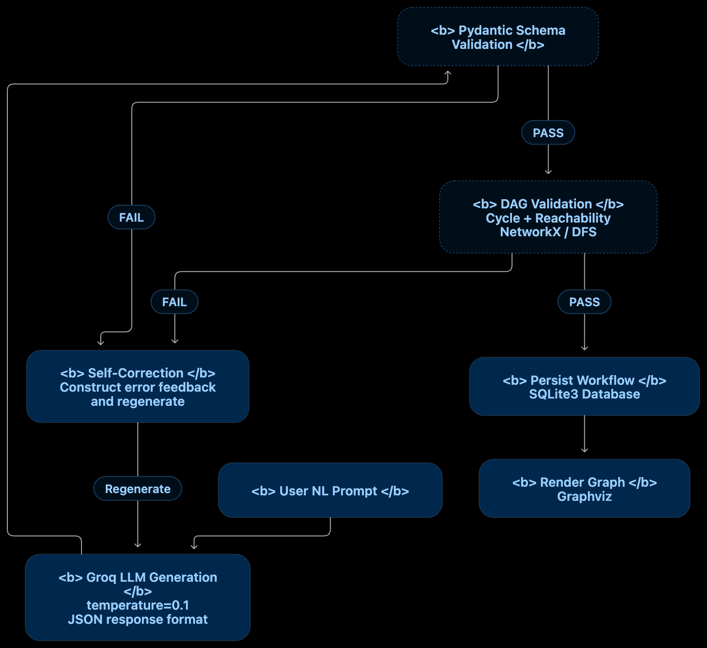

6.3 Validation Rules
# | Rule | Layer
V1 | Payload matches the schema (required fields, enums, types) | Pydantic
V2 | Node IDs are unique | Pydantic
V3 | entrypoint references an existing node | Graph
V4 | All edge endpoints reference existing nodes | Graph
V5 | Graph is acyclic | NetworkX
V6 | Every node is reachable from entrypoint | DFS
V7 | condition nodes have outgoing edges for both true and false | Graph
V8 | condition_branch appears only on edges leaving a condition node | Graph
V9 | fallback_node references an existing node | Graph
V10 | tool_name and endpoint exist in the registry | Registry
V11 | Template paths reference only known context keys or upstream nodes | Static analysis

6.4 Retry Policy
- Max 3 correction attempts.
- Each retry sends the previous output plus a structured error list ([{"rule": "V5", "detail": "cycle: a -> b -> a"}]).
- After exhaustion, return 422 with the last error set.

7. Execution Runtime

7.1 Execution State Machine
- PENDING: Workflow initialized, waiting to start.
- RUNNING: Active node traversal underway.
- WAITING_APPROVAL: Paused at a human_approval node.
- COMPLETED: All execution paths finished successfully.
- FAILED: Execution terminated due to unhandled errors or rejection.

7.2 Traversal Algorithm
- Init: create the execution row and context = trigger_payload.
- Loop starting at entrypoint:
  - Resolve templates in the node config from context.
  - Dispatch to the handler for node.type.
  - On success, write the output to context.nodes[node_id].output and log a SUCCESS step.
  - On failure, apply the on_error policy (7.4).
  - Select the next node:
    - condition: follow the edge whose condition_branch matches the result.
    - Otherwise: follow the single outgoing edge.
  - Persist current_node_id and context_data after every node.
- Human approval: set status to WAITING_APPROVAL, insert an APPROVAL_REQUEST, persist state, and return (do not block a thread).
- Completion: when no outgoing edge remains, set COMPLETED.

7.3 Resume Flow
- POST /executions/{id}/approve or /reject loads state, records the decision and comment, then:
  - Approve: sets status to RUNNING and continues from the node after the approval node.
  - Reject: marks the execution FAILED (see 13.5 for a rejection-branch option).
- Resume must be idempotent: a second decision on an already-resolved request returns 409.

7.4 Error Handling
node fails

├─ attempts < retry_count? → wait retry_delay_seconds, retry

├─ fallback_node defined? → route to fallback_node

├─ fail_workflow == true? → status FAILED

└─ else → store default output, continue

7.5 Handler Contract
class NodeHandler(Protocol):

def execute(self, config: dict, context: dict) -> dict:

"""Return an output dict. Raise NodeExecutionError on failure."""

One handler per node type, registered in a dispatch map.

8. Data Model

8.1 ER Diagram Relationships
- WORKFLOW has zero or many WORKFLOW_EXECUTION records.
- WORKFLOW_EXECUTION produces zero or many STEP_LOG records.
- WORKFLOW_EXECUTION triggers zero or many APPROVAL_REQUEST records.

8.2 SQLite DDL Schema
PRAGMA journal_mode = WAL;

PRAGMA foreign_keys = ON;

CREATE TABLE workflow (

id TEXT PRIMARY KEY,

name TEXT NOT NULL,

natural_prompt TEXT,

graph_definition TEXT NOT NULL, -- JSON

created_at TEXT NOT NULL DEFAULT (datetime('now'))

);

CREATE TABLE workflow_execution (

id TEXT PRIMARY KEY,

workflow_id TEXT NOT NULL REFERENCES workflow(id),

status TEXT NOT NULL CHECK (status IN

('PENDING','RUNNING','WAITING_APPROVAL','COMPLETED','FAILED')),

context_data TEXT NOT NULL, -- JSON

current_node_id TEXT,

started_at TEXT,

completed_at TEXT

);

CREATE TABLE step_log (

id TEXT PRIMARY KEY,

execution_id TEXT NOT NULL REFERENCES workflow_execution(id),

node_id TEXT NOT NULL,

node_type TEXT NOT NULL,

input_payload TEXT,

output_payload TEXT,

status TEXT NOT NULL CHECK (status IN ('SUCCESS','FAILED','SKIPPED')),

error_message TEXT,

execution_time_ms REAL,

timestamp TEXT NOT NULL DEFAULT (datetime('now'))

);

CREATE TABLE approval_request (

id TEXT PRIMARY KEY,

execution_id TEXT NOT NULL REFERENCES workflow_execution(id),

node_id TEXT NOT NULL,

prompt TEXT NOT NULL,

required_role TEXT,

status TEXT NOT NULL CHECK (status IN ('PENDING','APPROVED','REJECTED')),

decision_comment TEXT,

requested_at TEXT NOT NULL DEFAULT (datetime('now')),

resolved_at TEXT

);

CREATE INDEX idx_exec_status ON workflow_execution(status);

CREATE INDEX idx_step_exec ON step_log(execution_id);

CREATE INDEX idx_appr_status ON approval_request(status);

9. REST API
Method | Path | Purpose
POST | /workflows/generate | NL prompt to validated workflow (not yet persisted)
POST | /workflows | Save a workflow (after optional JSON edits)
GET | /workflows/{id} | Fetch a workflow
POST | /workflows/{id}/execute | Start an execution with a trigger payload
GET | /executions/{id} | Status, context, current node
GET | /executions/{id}/steps | Step logs
POST | /executions/{id}/approve | Approve the pending request
POST | /executions/{id}/reject | Reject the pending request

Example: Generate Request and Response
Request:POST /workflows/generate

Content-Type: application/json

{

"prompt": "If a refund exceeds $500, check fraud score, ask manager approval, then issue Stripe refund"

}

Response:{

"workflow": {

"id": "wf_...",

"entrypoint": "...",

"nodes": [],

"edges": []

},

"validation": {

"attempts": 1,

"warnings": []

}

}

Error codes: 422 validation failed after retries, 404 unknown ID, 409 invalid state transition (e.g. approving a non-waiting execution), 502 LLM provider error.

10. Frontend (Streamlit)

Tab 1: Workflow Generator and Visualizer
- Prompt textbox plus quick templates:
  - High-Value Refund & Fraud Prevention
  - Customer Onboarding & Verification
  - Server Incident Escalation & DevOps Remediation
- Generate Workflow button (calls Groq via the backend).
- Graphviz flowchart visualization styling:

Node Category | Shape | Color
api, tool | Rectangle | Green
condition | Diamond | Orange
human_approval | Hexagon | Blue
Error / fallback nodes | Circle | Red

- Raw JSON inspector/editor (edits are re-validated before save).

Tab 2: Runner and Console
- Trigger payload input (pre-filled from sample_input).
- Run Execution button.
- Live step cards: node label, status, elapsed ms, input/output diff.
- Approval gate: banner (for example "Manager Approval Required: Approve refund of $850 for jane@example.com?") with [Approve & Continue] and [Reject Workflow].
- Final summary and JSON output viewer.

11. Security Considerations
Risk | Mitigation
Code injection via expressions | Safe evaluator only; no eval/exec
LLM-hallucinated or malicious endpoints | Allowlist registry; reject unknown hosts (V10)
SSRF via api nodes | Block private IP ranges; enforce host allowlist
Prompt injection in the user prompt | Schema-constrained output plus post-validation; the LLM output is data, never instructions
Secrets exposure | Load Groq and API keys from env vars; never place them in the IR or logs
PII in step logs | Redact configured fields (e.g. customer_email) before persisting
Unauthorized approvals | Enforce required_role against the caller identity (v1: label only)
Double approval / replay | Idempotent decisions; 409 on resolved requests

12. Testing Strategy

12.1 Acceptance Tests
ID | Scenario | Expected Behavior
TC-01 | Valid DAG generation from a refund prompt | Valid JSON, no cycles, starts at a validation node
TC-02 | Conditional branching (risk > 0.7 vs <= 0.7) | Routes to the approval path or the automatic path correctly
TC-03 | Human-in-the-loop | Engine pauses, status is WAITING_APPROVAL, resumes on approval
TC-04 | Data transformation (tax/fee math) | Node output propagates to downstream API input
TC-05 | Error handling and retry | Retries run, then redirect to the fallback alert on exhaustion

12.2 Recommended Additions
ID | Scenario | Expected Behavior
TC-06 | Cyclic graph from the LLM | Rejected by V5; self-correction triggered
TC-07 | Rejected approval | Execution ends FAILED; step log records the rejection
TC-08 | Restart during WAITING_APPROVAL | State reloads from SQLite; approval still resumes
TC-09 | Double-approve | Second call returns 409
TC-10 | Missing template variable | TemplateResolutionError handled via on_error
TC-11 | Malicious expression (__import__('os')) | Blocked by the safe evaluator
TC-12 | LLM returns invalid JSON 3 times | 422 with the aggregated validation errors

12.3 Test Layers
- Unit: validators, expression evaluator, each node handler.
- Integration: full execute/pause/resume against a temp SQLite file.
- LLM: record/replay fixtures (VCR-style) so CI does not call Groq.

13. Known Inconsistencies and Open Questions
These exist between the design doc and the schema spec. Resolve before implementation.

13.1 Config field names differ
Node | Design doc (§3.1) | Schema example | Recommendation
api | url, payload_template | endpoint, payload | Use endpoint and payload
human_approval | approver_role | required_role | Use required_role (matches APPROVAL_REQUEST)
notification | message_template | message | Use message
tool | score_fraud | fraud_detector | Pick one name in the tool registry

13.2 Branch routing model
Design doc §3.1 says condition nodes route to if_true / if_false in config. The schema routes via condition_branch on edges. Recommendation: use edges only (single source of truth, easier to validate and visualize).

13.3 retry_delay_seconds
Present in design doc §3.2, absent from the JSON Schema on_error definition. Add it to the schema.

13.4 Node ID convention
The design doc mandates node_1, node_2, but the schema example uses descriptive IDs (step_validate_request). Descriptive IDs help debugging and make LLM references clearer. Decide one convention and enforce it in the validator.

13.5 Rejection behavior
Rejection currently ends the workflow. Consider allowing a reject edge (condition_branch: "false" on approval nodes, or a dedicated "rejected" value) so rejections can trigger notifications.

13.6 timeout_seconds on approvals
Listed in config but no expiry mechanism is defined. Needed: a background sweeper that marks timed-out requests and fails or escalates the execution.

13.7 Sequential execution only
The traversal assumes a single outgoing edge for non-condition nodes. Define whether multiple outgoing edges are a validation error (recommended for v1) or fan-out.

13.8 transform mapping syntax
The example {"total": "$.subtotal + $.tax"} uses JSONPath-style $, but section 5 uses context. paths. Standardize on one.

13.9 Missing default branch semantics
condition_branch allows "default", but no behavior is specified. Define it (e.g. fallback when the expression errors) or remove it.

14. Local Development
# 1. Environment

python -m venv .venv && source .venv/bin/activate

pip install fastapi uvicorn streamlit pydantic networkx graphviz groq simpleeval httpx pytest

# 2. System dependency (for Graphviz rendering)

# macOS: brew install graphviz

# Ubuntu: sudo apt-get install graphviz

# 3. Config

export GROQ_API_KEY=your_key_here

export DB_PATH=./workflows.db

# 4. Run

uvicorn app.main:app --reload --port 8000 # backend

streamlit run ui/app.py # frontend

# 5. Test

pytest -q

Suggested Repository Layout
.

├── app/

│ ├── main.py # FastAPI entrypoint

│ ├── api/ # route modules

│ ├── compiler/ # Groq client, prompts, self-healing loop

│ ├── validation/ # Pydantic models, graph checks

│ ├── engine/ # traversal, state machine, handlers/

│ ├── registry/ # tool + API allowlists

│ └── db/ # schema.sql, repositories

├── ui/

│ └── app.py # Streamlit

├── tests/

│ ├── unit/

│ ├── integration/

│ └── fixtures/ # recorded LLM responses

└── README.md

